# **Usage Instructions**

## **Form Usage Instructions:**

### 1. Inserting Data with Forms:

### Open the Access Database:

*Open Microsoft Access and load the database created using the ODBC link ("Assignment2_last").*

*Navigate to Forms:*

*Find the "Forms" section in the Access database.*

*Open the Form for Data Insertion:*

*Identify the form designed for data insertion. This could be named "frmCustomers" for the Customers table, or similar.*

*Insert New Data:*

*Once the form is open, you will see input fields for various customer details.*

*Enter the required information such as first name, last name, phone number, etc.*

*After filling in the information, you can either:*

*Click the "Save" button to save the entered data into the main table (e.g., Customers).*

*Click the "Undo" button to discard the changes if needed.*

*Use of Save, Undo, and Go to History Buttons:*

***

***Then we have Problem form as we mentioned previously. You can navigate through form by clicking provided buttons.***

Save Button: Clicking "Save" will commit the entered data to the main table.

Undo Button: Clicking "Undo" will discard the changes made and revert to the original data.

**Invoice form to add invoices to the bikes purchased**

**All the repair details will be in REPAIR DETAILS form**

Go to History Button: If available, this button allows you to navigate to the history table to view historical changes.

We have Three History Forms

1. **PROBLEM_HISTORY**

1. **We have CUSTOMERS_HISTORY**

1. **We have INVOICE_HISTORY**

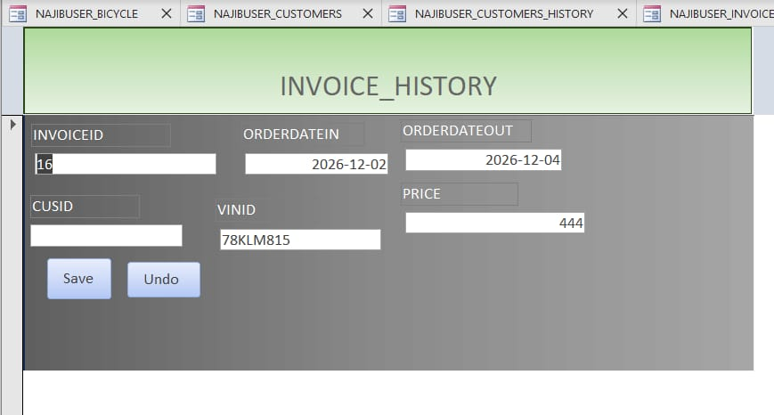

**2. Accessing Reports:**

Navigate to Reports:

Find the "Reports" section in the Access database.

Open the Desired Report:

1. **Problem_History Report**

1. **BICYCLE REPORT**

1. **PROBLEM REPORT**

1. **MECHANIC REPORT**

1. **CUSTOMERS_HISTORY REPORT**

1. **CUSTOMERS REPORT**

1. **INVOICE REPORT**

1. **INVOICE_HISTORY REPORT**

Identify the report you want to view. For example, a report named "rptCustomerInvoices" or "rptRepairDetails."

***Viewing Data in Reports:***

*Open the selected report to view organized and formatted data.*

*Reports are designed to provide a clear and comprehensive view of specific data relationships or details.*

*Navigating Data in Reports:*

*Reports typically offer navigation features, allowing you to move through pages or sections.*

*Use the provided navigation tools or buttons to browse through the report.*